**Creating the HBase Table:**

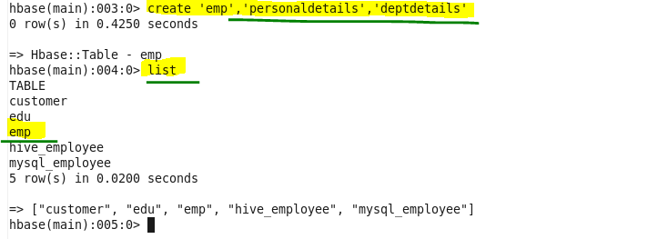

**Insert the data into HBase table:**

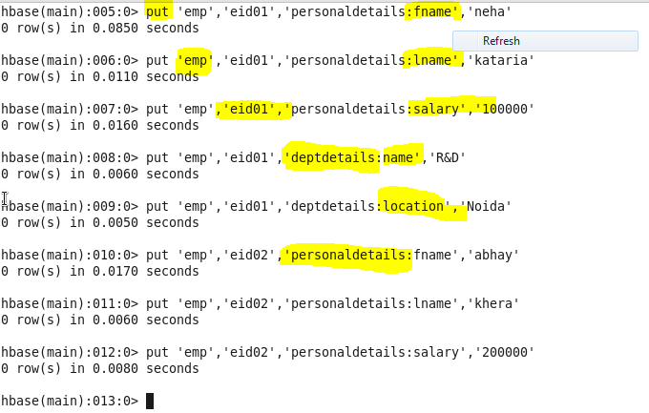

**Creating the Hive table pointing to HBase table:**

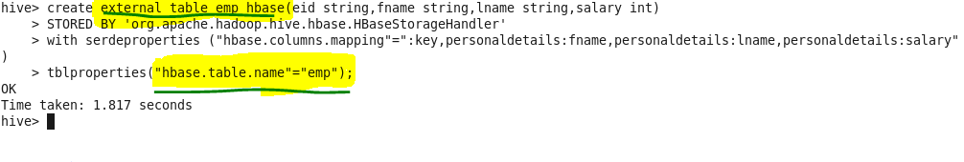

**Output :**

